**System Interfaces**

* **User Interfaces:**
  + The users in our website are classified into:
    1. Owners of the startups
    2. Customers
* The Owner will be able to:
  + See all the categories (co-working spaces, cafés, and restaurants), so he can choose any of them.
  + Sign up to the website.
  + Login to the website where he can get the available promo codes.
  + Get in contact to the website owners in ‘contact us’ page.
  + Add, edit or delete his project.
  + Add a detailed description of his project (images, location, menus, offers…etc).
  + See the reviews of his project.
  + Set the number of available promo codes per day.
  + Get notified by taken promo codes.
  + The Customer will be able to:
    - See all the categories (co-working spaces, cafés, and restaurants), so he can choose any of them.
    - See the reviews of certain projects.
    - Sign up to the website.
    - Login to the website where he can get the available promo codes.
    - See the description of each project.
    - Get in contact to the website owners in ‘contact us’ page.
    - Report certain projects if any issue happen.
    - See the description of the website in ’About’ page.
  + Examples on Interfaces
    - Sign up form

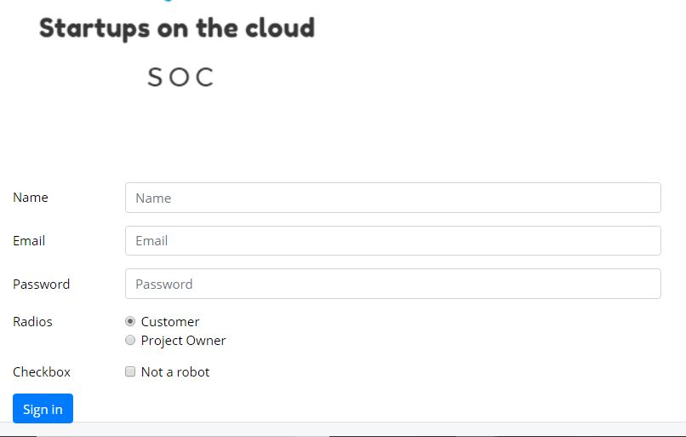

* + - Login form

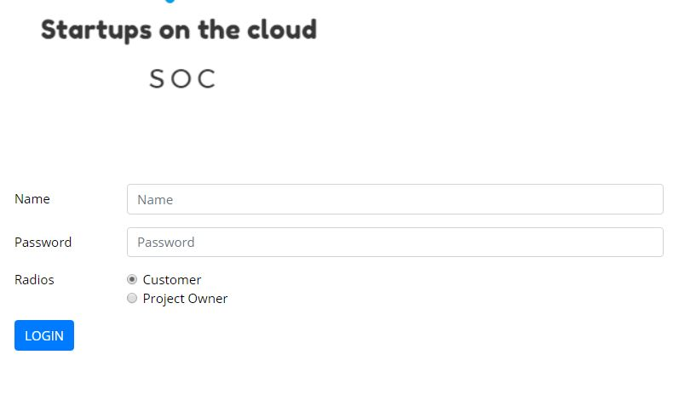

* + - Certain Category page

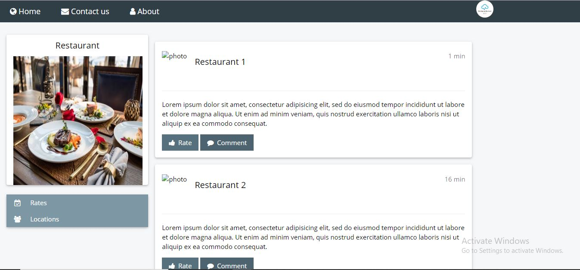

* + - Project Owner page

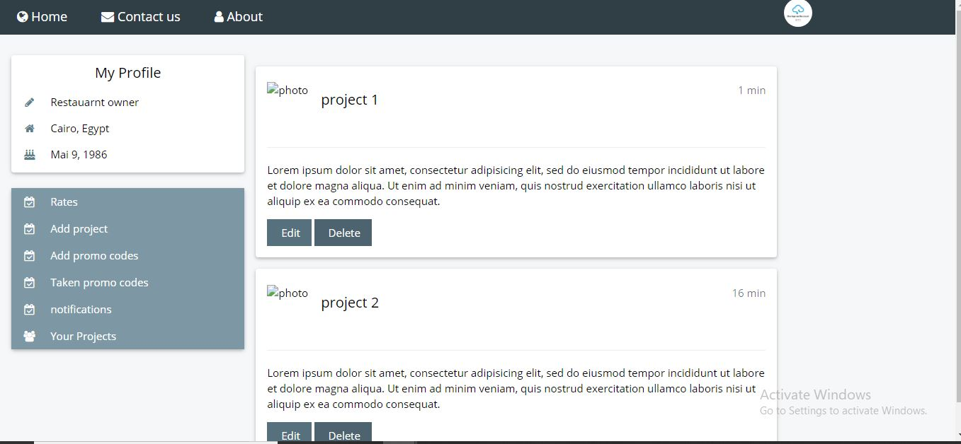

* + - Contact Us

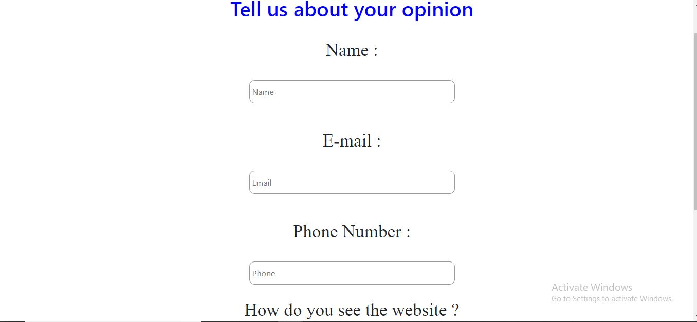

* **Hardware interfaces**

There is no hardware interfaces